Big Data Project – Report 2
Iceland Short-Term Wind Forecast & Extreme Wind Alerts
Mis à jour: 28/11/2025
Tengzhe ZHANG

Cluster map
This section describes which component runs on which VM and on which port.

Nodes and roles
Node | IP | Role
master | 10.0.0.36 | HDFS NameNode, DataNode, YARN ResourceManager, Kafka broker #1, ZooKeeper, Spark driver/executors, Time-series DB, Grafana
worker1 | 10.0.0.37 | HDFS DataNode, YARN NodeManager, Kafka broker #2, Spark executors

Component-level cluster map
Component | Role | Host:Port | Notes
HDFS NameNode | Metadata service | master:9000 | dfs.namenode.name.dir=/usr/local/hadoop/data/namenode
HDFS DataNode | Block storage | master, worker1 | dfs.datanode.data.dir=/usr/local/hadoop/data/datanode
YARN ResourceManage | Cluster scheduler | master:8088 | Manages Spark/YARN containers
YARN NodeManager | Container agent | master, worker1 | Runs individual Spark executors
Spark Driver | Streaming job driver | master (YARN client mode) | Submitted via spark-submit --master yarn --deploy-mode client
Spark Executors | Run the streaming computation | YARN containers on master/worker1 | Automatically scheduled by YARN
ZooKeeper | Kafka coordination service | master:2181 | Handles Kafka cluster metadata and broker registration
Kafka Broker #1 | Main Kafka entrypoint for producers/consumers | master:9092 | log.dirs=/data/kafka/broker
Kafka Broker #2 | Second broker for availability / scalability | worker1:9093 | log.dirs=/data/kafka/broker
Kafka topic | Raw wind data stream | — | Topic name: weather_iceland_raw, 3 partitions, replication-factor=1
Time-series DB (InfluxDB) | Stores aggregated wind-speed time series | master:8086 | store aggregated metrics
Grafana | Dashboard frontend | master:3000 | Reads wind metrics from the TSDB for visualization
HDFS path – raw data | Landing zone for raw Kafka data | hdfs:///data/weather/raw | Spark Structured Streaming output path
HDFS path – checkpoints | Spark state and Kafka offsets | hdfs:///checkpoints/weather_raw | Used for exactly-once semantics and fault tolerance

Architecture description
This section shows how components connect (topics, checkpoints, tables, ports).

Data flow overview
- External data source → Kafka
A Python producer periodically calls a weather API to fetch 48-hour wind forecasts.
The producer converts each forecast record into one JSON/CSV line and sends it to the Kafka topic weather_iceland_raw, using: bootstrap.servers=master:9092,worker1:9092

- Kafka → Spark Structured Streaming
On master, we submit the spark_streaming_job.ipynb via spark-submit. The core input logic is:
df = (spark.readStream
.format("kafka")
.option("kafka.bootstrap.servers", "master:9092,worker1:9092")
.option("subscribe", "weather_iceland_raw")
.option("startingOffsets", "latest")
.load())

The streaming job converts the Kafka value from binary to string and parses fields such as location, timestamp, wind_speed, etc.

- Spark → HDFS
The raw or lightly cleaned data is written to HDFS:
query = (parsed_df.writeStream
.format("parquet") # or "csv"
.option("path", "/data/weather/raw")
.option("checkpointLocation", "/checkpoints/weather_raw")
.outputMode("append")
.start())
/data/weather/raw: landing directory in HDFS.
/checkpoints/weather_raw: checkpoint directory. Spark maintains here:<Which Kafka offset has already been processed>; <The streaming job’s state (e.g., watermarks, window aggregates)>.

- Spark → Time-series DB (planned)
In a later version, the same streaming job will be extended with another branch:
- Within each micro-batch, aggregate by location and time window (e.g., 10 minutes / 1 hour);
- Compute metrics such as average/max wind speed and gust speed;
- Use foreachBatch or writeStream.format("org.influxdb.spark") to write the aggregates into InfluxDB (master:8086).
The TSDB will thus store pre-aggregated time series, making it easy for Grafana to query.

- Time-series DB → Grafana (planned)
- Use InfluxDB as a data source;
- Build dashboards, for example: Time series of wind speed around Reykjavík / Keflavík, Comparison of wind speed between the north (Akureyri) and the southwest (Reykjavík/Keflavík).

Connection diagram
In the report, we can include a diagram with roughly the following structure:
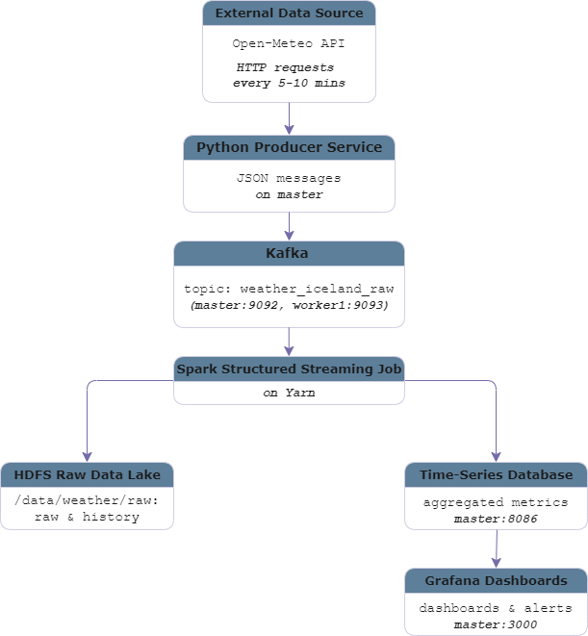

Little demo
This section shows the output of each step by screenshots

Hadoop Cluster Online
- Screenshot 1 – Java processes on master and worker1
Commands:
# On master (as user hadoop)
jps

# From master, check worker1
ssh worker1 'jps'
Output:
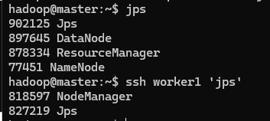

This demonstrates that HDFS and YARN are up and running on both nodes.

- Screenshot 2 – HDFS directories for raw data and checkpoints
Commands:
# On master (as user hadoop)
hdfs dfs -ls /data
hdfs dfs -ls /checkpoints

Output:
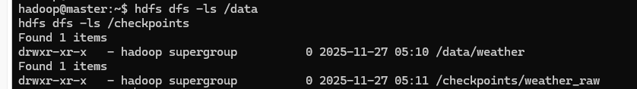
This confirms that the storage layout for the Kafka → Spark → HDFS pipeline is in place.

Kafka / Zookeeper Running
- Screenshot 3 – Zookeeper and Kafka listening ports
Commands:
# On master (as user kafka)
bin/zookeeper-shell.sh master:2181 <<< "ls /brokers/ids"

Outouts:
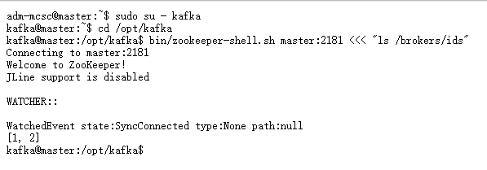
This proves that the Zookeeper + 2 Kafka cluster is alive and reachable.

- Screenshot 4 – Kafka topic description
Commands:
# On master (as user kafka)
bin/kafka-topics.sh --describe \
--topic weather_iceland_raw \
--bootstrap-server master:9092

Outputs:
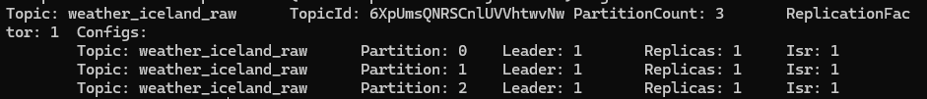
This confirms that the input topic for the streaming pipeline has been created correctly.

Spark Structured Streaming Job
- Screenshot 5 – spark-submit terminal
Commands:
pt/spark/bin/spark-submit \
--master yarn \
--deploy-mode client \
--packages org.apache.spark:spark-sql-kafka-0-10_2.12:3.5.7 \
spark_streaming_job.py
Outputs:
(During the past two days the master VM1 has been unstable. Whenever I reach the Spark Structured Streaming step, the VM frequently becomes unresponsive or crashes, which makes it very difficult to keep the cluster running long enough to collect the required screenshots.
I was able to successfully run the Kafka → Spark Structured Streaming → HDFS pipeline several times (the job started on YARN and data was written under /data/weather/raw), but at these times I did not capture the screenshots. After that run, repeated attempts to rerun the job often caused the master VM to hang.
After IT restarts the VM1, I will rerun the experiment and complete the missing screenshots once VM1 has been reset and the environment is stable again.)

This demonstrates that the Spark Structured Streaming job is running and connected to the Kafka topic.

Data Landing in HDFS
- Screenshot 6 – Files written to /data/weather/raw
Commands:
hdfs dfs -ls /data/weather/raw

Outputs:

This shows a few sample rows (location, timestamp, wind speed, etc.), making the data content explicit.

Github Link
https://github.com/1mol-272/projet_esilv/tree/main/BigData/Iceland_Short-Term%20Wind%20Forecast_Extreme%20Wind%20Alerts

